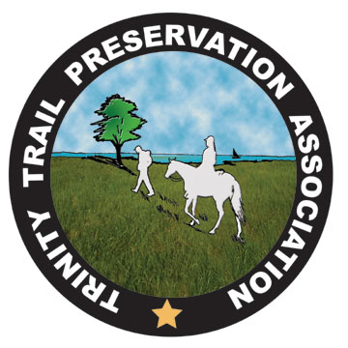

TTPA OBSTACLE COMPETITION
Saturday, Sept. 17, 2011 (Rain Date Sept. 24)
If all dates are rained out, checks will be returned.

Registration Form

Name_____________________________________________________

Address____________________________________________________

Tel. No ____________________________________________________

Email_______________________________________________________

Division: Pleasure-Adult __________ Pleasure-Youth __________
Advanced-Adult __________ Advanced-Youth __________
Pre-registration
TTPA Member $20 Non-Member $30
Day of Event (Closes 9:30 AM)
TTPA Member $25 Non-Member $35

Mail registration form with check payable to TTPA by Sept. 13 to:
Kris McFarland
1512 Evergreen Drive
Allen, TX 75002

Contestants under the age of 16 years must wear a helmet and be accompanied by an adult. All horses must have negative Coggins. Please no dogs.

For further information contact Tracy Matern at bobtracy@dfwair.net or 214-495-7493 (home) or 214-392-2288 (cell).

